CyberChef Basics - Lab Report

Date: 19/06/2026
Difficulty: Easy
Category: Defensive security tools
Platform: TryHackMe

Overview

This lab covers the basics for defensive security tool – CyberChef. This lab looks at what CyberChef is and how it can be used including practical examples of extracting data from an input file and also encoding/decoding text and URLs.

2. Toolset Used

Tool | Purpose / Function
CyberChef | A web-based application created to help with cyber operations within your web browser. It is a data Swiss army knife as it has a toolbox of different tools to do specific tasks. These tasks include encoding like XOR or Base 64 to AES OR RSA encryption/decryption

3. What I did

CyberChef is a web-based application created to help with cyber operations within your web browser. It is a data Swiss army knife as it has a toolbox of different tools to do specific tasks. These tasks include encoding like XOR or Base 64 to AES OR RSA encryption/decryption. CyberChef can be accessed either through the browser on this link (https://gchq.github.io/CyberChef/) or by downloading the latest release file from the internet and running it on your local machine.

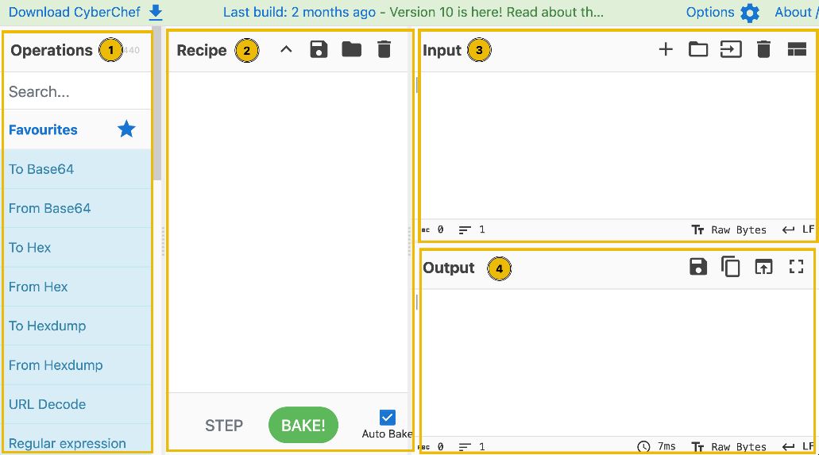

The interface has 4 sections as shown above. The operations section shows all the operations that this toolbox contains such as Base64, Hex and so on. Some common ones include URL encode which encodes problematic characters into percent-encoding which is a format that is supported by URLs, To Hex, Decimal and Base64 can be used to encode text into raw data which cannot be easily identified. The recipe section is the main bit and is where you can select, arrange and set operations to suit your needs. You can save, load or clear recipe which ae added features for this section. The input section is where the user inputs the text or files by pasting, typing or dragging them into the space. Finally, the output section shows the data processing results in a clean and clear space. From there you can save output to a file or copy the output to your clipboard.

There are 4 steps in the CyberChef process:

- Set a clear objective
- Put your data into the input area
- Select the operations you might want to use
- Check the output to see if it is the intended result

Extractors include extracting IP addresses, extracting URLs and extracting email addresses from input. Date and time convert a UNIX timestamp to a datetime string or parses a datetime string in UTC and returns the corresponding UNIX timestamp.

To show how this works, I downloaded the file from TryHackMe and opened CyberChef. I put the file as the input and then dragged the extract email addresses into the recipe section first which revealed an email address.

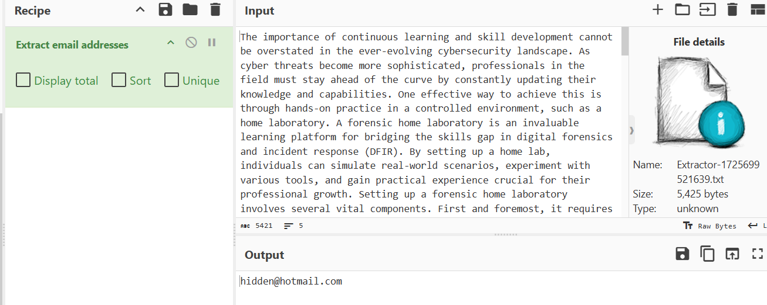

I then changed it to extract IP addresses to see the IP addresses available

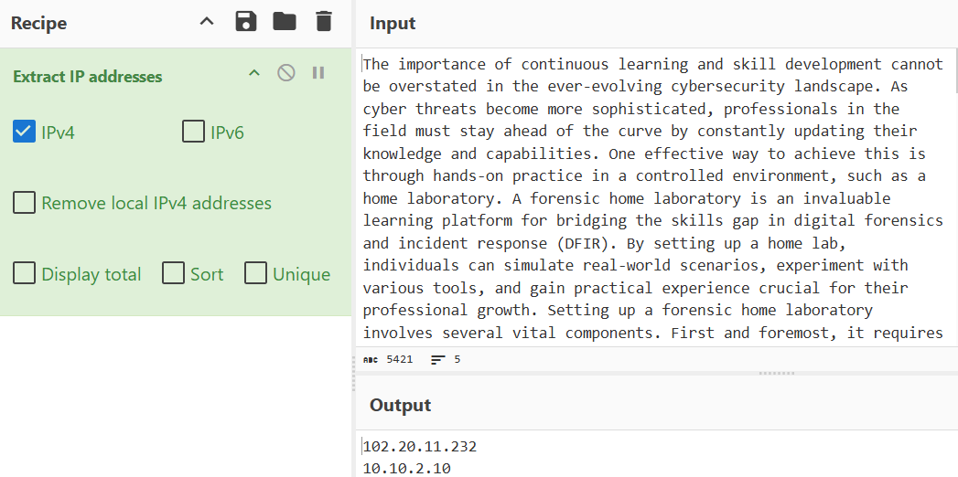

To see the binary value of decimal 78, I used the from decimal + to binary operators

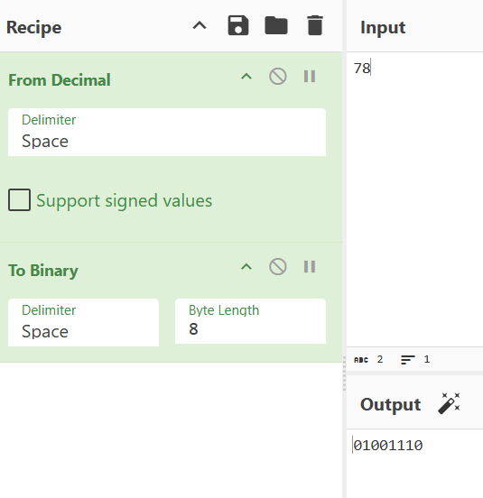

To encode an URL, I put the URL in the input section and then used the URL encode operator and ticked the all special chars box to encode each special character in the URL
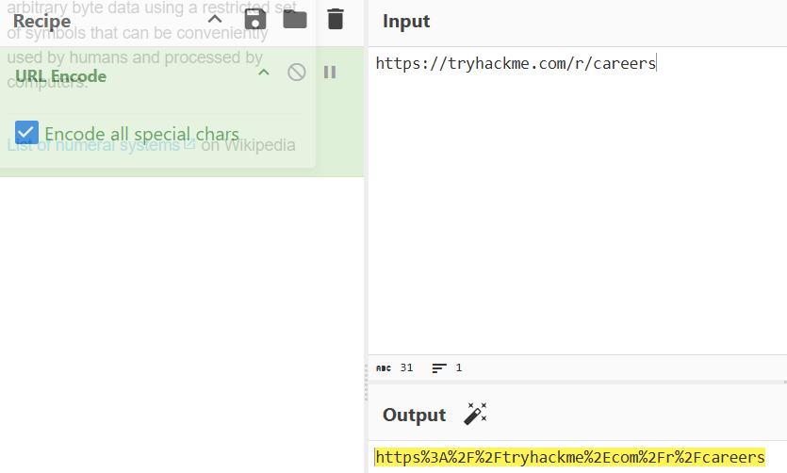

4. What I’ve learned

- What CyberChef is
- What each section does
- How to input a file and extract data from it such as IP and email addresses
- Encode and decode URLs
- Encode and decode text

